**Parameter Calculation References**

**Total Unit Weight**

*(Equation 1)*

Bowles (1968)

*(Figure 1)*

Robertson & Cabal (2022)

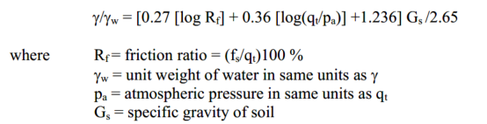 *(Equation 2)*

**Undrained Shear Strength**

Stroud (1974), From FHWA-NHI-16-072

*“𝑁60 is the SPT blow count corrected for hammer energy, 𝑝𝑎 is atmospheric pressure in the desired units, and 𝑓1 is an empirical coefficient that is taken to be equal to 4.5 for 𝑃𝐼 ≳ 30 and equal to 5.5 for 𝑃𝐼 ≅ 15. The relationship between 𝑁60 and 𝑠𝑢 is subject to considerable scatter, but the values of 𝑓1 proposed by Stroud generally represent somewhat lower bound values”*

*(Equation 3)*

McGregor and Duncan (1998), From Performance and Use of the Standard Penetration Test in Geotechnical Engineering Practice (CGPR #12)

*(Figure 2)*

NCHRP (2007), Synthesis 368

“The classical approach to evaluate undrained shear strength (Su) from CPT readings is through the net cone resistance”

*(Equation 4)*

**Effective Friction Angle**

Wolff (1989), “Pile capacity prediction using parameter functions.” sponsored by Geotechnical Engineering Division, ASCE, Evanston, Ill., June 1989, ASCE Geotechnical Special Publication No. 23, 96–106.

*(Equation 5)*

Hatanaka and Uchida (1996), From FHWA-NHI-16-072

*“Hatanaka and Uchida (1996) proposed an alternative transformation between 𝜙′ and corrected SPT blow count, (𝑁1)60, based on direct measurements of 𝜙′ in triaxial cells using high-quality undisturbed samples of natural sands obtained by freezing the samples. The data used by Hatanaka and Uchida were obtained using an automatic trip hammer system with an efficiency of 78 percent. For an average state-of-practice hammer with 60 percent efficiency, the expression for peak 𝜙′ is:”*

*(Equation 6)*

*“It is important to recognize that these transformations were developed for relatively clean sands. Use of these correlations in, for example, micaceous sands is not recommended. The presence of mica in sand will tend to reduce the SPT blow count significantly below that which would be measured for the same sand without mica. However, the actual friction angle of clean sand and micaceous sand may not be significantly different when measured in laboratory triaxial tests. Laboratory triaxial tests should be performed on silty sand soils where more accurate values of 𝜙′ are required.”*

Dunham (1954), From Performance and Use of the Standard Penetration Test in Geotechnical Engineering Practice (CGPR #12)

*This method is indicated in CGPR #12 as developed for use with round and uniform grained soils particles.*

*(Equation 7)*

Terzaghi, Peck, and Mesri (1996), From FHWA-NHI-16-072

*“For clays, empirical correlations have been developed to relate φ’ to the plasticity characteristics of the soil … shows a slight trend of φ’ decreasing with increasing PI (Mesri and Abdel-Ghaffer, 1993), yet values can be ± 8º in variance.”*

*(Figure 3)*

NCHRP (2007), Synthesis 368

*(Equation 8)*

Sorrensen and Okkels (2013), From Correlation between drained shear strength and plasticity index of undisturbed overconsolidated clays

*It should be noted that some cases may dictate a mobilized angle of shearing resistance which is lower than the above estimated peak values, e.g. when progressive failure is considered in connection to slope stability analysis in high plasticity clays (Skempton 1977, Burland 1990).*

*The lower bound estimate for NC clays is shown in Figure 5 (dash-double-dot line) for comparison. It is observed that the lower bound estimates for NC and OC clays do not deviate much.*

*(Equation 9)*

*(Equation 10)*

Ladd et al (1977), From CGPR #4

*(Figure 4)*

**Elastic Modulus**

Tan et al. (1991), From CGPR #12

*Normally Consolidated Sand (units in kPa)*

*(Equation 11)*

*Gravelly Sand and Gravel (units in kPa)*

*(Equation 12)*

*(Equation 13)*

*Clayey Sand (units in kPa)*

*(Equation 14)*

*Silty Sand (units in kPa)*

*(Equation 15)*

Modified AASHTO (2014), From FHWA-NHI-16_072

*Silts, sandy silts, slightly cohesive materials (units in ksi)*

*(Equation 16)*

*Clean fine to medium sands and slightly silty sands (units in ksi)*

*(Equation 17)*

*Coarse sands and sands with little gravel (units in ksi)*

*(Equation 18)*

*Sandy gravels and gravels (units in ksi)*

*(Equation 19)*

NCHRP (2007), Synthesis 368

*“From elastic theory, the constrained modulus (D’) relates to the equivalent elastic Young’s modulus (E’ or Es) for drained loading conditions”*

*,*

*(Equation 20)*

**Void Ratio**

Basic Relationship

*(Equation 21)*

**Compression Index**

Kulhawy and Mayne (1990), From FHWA-NHI-16-072

*Linear regression from various methods including: Mayne (1980), Nakase et al (1988), Been et al (1987), Wesley (1988), Lambe & Whitman (1969), Olsen et al (1986), Imai et al (1984), Morin & Dawe (1987). This Method is intended for use with all clays*

*(Equation 22)*

Sowers (1963), From FHWA-NHI-16-072

*This relationship is noted in FHWA-NHI-16-072 as applicable for residual soils.*

*(Equation 23)*

Nagaraj and Srivasa Murthy (1986), From FHWA-NHI-16-072

*This relationship is noted in FHWA-NHI-16-072 as applicable for all clays.*

*(Equation 24)*

Moran et al (1958), From FHWA-NHI-16-072

*This relationship is noted in FHWA-NHI-16-072 as applicable for organic soils, peats, and clays.*

*(Equation 25)*

Rendon-Herrero (1983), From FHWA-NHI-16-072

*This relationship is noted in FHWA-NHI-16-072 as applicable for all clays.*

*(Equation 26)*

Azzouz et al (1976), From FHWA-NHI-16-072

*This relationship is noted in FHWA-NHI-16-072 as applicable for all clays.*

*(Equation 27)*

*(Equation 28)*

*(Equation 29)*

Terzaghi and Peck (1967)

*(Equation 30)*

**Recompression Index**

Kulhawy and Mayne (1990), From FHWA-NHI-16-072

*Linear regression from various methods including: Mayne (1980), Nakase et al (1988), Been et al (1987), Wesley (1988), Lambe & Whitman (1969), Olsen et al (1986), Imai et al (1984), Morin & Dawe (1987). This Method is intended for use with all clays*

*(Equation 31)*

Azzouz et al (1976)

*(Equation 32)*

*(Equation 33)*

*(Equation 34)*

Nagaraj and Srinivasa Murthy (1985), From Foundation Analysis and Design 5th edition, Bowles

*(Equation 35)*

Nakase et al (1988), From Foundation Analysis and Design 5th edition, Bowles

*(Equation 36)*

* *From Foundation Analysis and Design 5th edition a correlation is drawn from the compression index. The correlation is shown below:*

*(Equation 37)*

*These correlations are noted as only to be used in desperation and are discouraged if other data is available.*

**Preconsolidation Pressure**

Stas and Kulhawy (1984), From FHWA-NHI-16-072

*“Qualitatively, it is generally well known that the liquidity index, 𝐿𝐼, provides an indirect indication of stress history. Soils with 𝐿𝐼≥1 are typically normally consolidated while soils with 𝐿𝐼 ≤0 are typically moderately to heavily overconsolidated. Several attempts have been made to directly correlate 𝐿𝐼 to 𝑂𝐶𝑅 or 𝜎𝑝′ for different soils. For soils with sensitivity between 1 and 10, Stas and Kulhawy (1984) suggested that 𝜎𝑝′ is related to 𝐿𝐼 as”*

*(Equation 38)*

NAVFAC Volume 7.1

*“For samples with natural moisture at the liquid limit (liquidity index of 1), preconsolidation ranges between about 0.1 and 0.8 tsf depending on soil sensitivity. For natural moisture at the plastic limit (liquidity index equal to zero), preconsolidation ranges from about 12 to 25 tsf.”*

*(Equation 39)*

NCHRP (2007), Synthesis 368

*“For intact clays, a first-order estimate of the preconsolidation stress (σ’p) can be obtained from the net cone tip resistance (qt) and total vertical overburden stress (σv) using the following equation.”*

*(Equation 40)*

EPRI (1990), EL-6800

*(Figure 5)*

**Coefficient of Consolidation**

NAVFAC Volume 7.1

*“Sample disturbance decreases coefficient of consolidation for both recompression and virgin compression. For an undisturbed sample, c+v, usually decreases abruptly at preconsolidation stress. This trend is not present in badly disturbed samples.”*

*(Figure 6)*

Terzaghi, Peck, and Mesri (1996), From CGPR #54

*“ the value of cv is practically constant in the recompression range. In the compression range, it either remains constant or increases moderately with pressure. Data on cv in the compression range for a large number of clays are plotted in Fig 25.7. Although in a general way cv decreases with increasing liquid limit, for clays with a given liquid limit cv varies widely”*

*(Figure 7)*

**Permeability**

Beyer (1964), From ISSMGE (2021): Prediction of permeability coefficient for Quaternary Sediments of Drava River using different empirical correlations

*“The formula developed by Beyer [11] has took into account the uniformity coefficient as a function of permeability. Beyer’s data suggest an inverse relationship between CU and k. This equation does not consider porosity and most useful for materials poorly graded with heterogeneous distributions, with uniformity coefficient between 1 and 20, and effective grain size between 0.06 mm and 0.6 mm. The equation can be expressed as follows:”*

*(Equation 41)*

WES TM No. 3-424, ref. A-1, From EM 1110-2-1913 dated April 2000

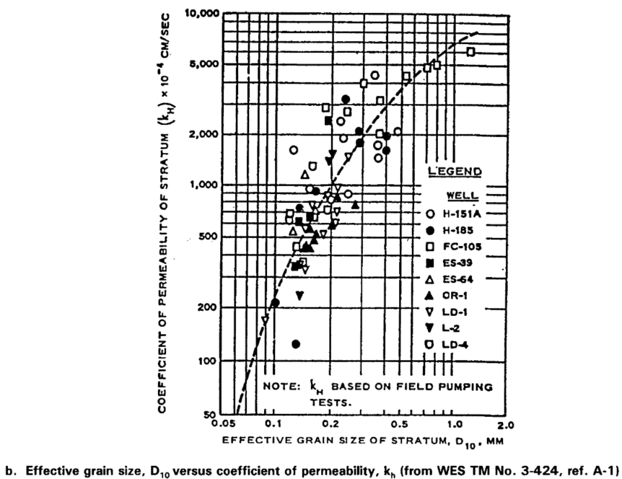

*(Figure 8)*

URS 2015, From EM 1110-2-1913 dated December 2023

*(Figure 9)*

**References**

*Bowles (1968)  
Bowles, J.E. (1968). Foundation Analysis and Design. McGraw-Hill Book Company, New York.*

*Robertson & Cabal (2022)  
Robertson, P.K., & Cabal, K.L. (2022). Guide to Cone Penetration Testing for Geotechnical Engineering. 6th Edition, Gregg Drilling & Testing, Inc.*

*Stroud (1974)  
Stroud, M.A. (1974). “The Standard Penetration Test in Insensitive Clays and Soft Rocks,” Proceedings of the European Symposium on Penetration Testing.*

*FHWA-NHI-16-072 (2016)  
Federal Highway Administration (2016). Evaluation of Soil and Rock Properties. National Highway Institute, Report No. FHWA-NHI-16-072.*

*McGregor and Duncan (1998)  
McGregor, J.A., & Duncan, J.M. (1998). Performance and Use of the Standard Penetration Test in Geotechnical Engineering Practice (CGPR #12). Center for Geotechnical Practice and Research.*

*NCHRP (2007), Synthesis 368  
National Cooperative Highway Research Program (2007). Cone Penetration Testing: State of the Practice. Synthesis Report 368, Transportation Research Board, Washington, D.C.*

*Wolff (1989)  
Wolff, T.F. (1989). “Pile Capacity Prediction Using Parameter Functions,” ASCE Geotechnical Special Publication No. 23, Geotechnical Engineering Division, American Society of Civil Engineers, pp. 96–106.*

*Hatanaka and Uchida (1996)  
Hatanaka, M., & Uchida, A. (1996). “Correlation of SPT Blow Count with Shear Strength Parameters of Sands,” Soils and Foundations, Japanese Geotechnical Society.*

*Dunham (1954)  
Dunham, C.W. (1954). Performance and Use of the Standard Penetration Test in Geotechnical Engineering Practice (CGPR #12).*

*Terzaghi, Peck, and Mesri (1996)  
Terzaghi, K., Peck, R.B., & Mesri, G. (1996). Soil Mechanics in Engineering Practice (3rd Edition). Wiley, New York.*

*NCHRP (2007), Synthesis 368  
National Cooperative Highway Research Program (2007). Cone Penetration Testing: State of the Practice. Synthesis Report 368.*

*Sorrensen and Okkels (2013)  
Sorrensen, K.K., & Okkels, N. (2013). “Correlation Between Drained Shear Strength and Plasticity Index of Undisturbed Overconsolidated Clays,” Geotechnical Testing Journal, ASTM International.*

*Skempton (1977)  
Skempton, A.W. (1977). “Progressive Failure in Slopes in Overconsolidated Clays,” Geotechnique, Vol. 27, No. 2, pp. 115–134.*

*Burland (1990)  
Burland, J.B. (1990). “On the Compressibility and Shear Strength of Natural Clays,” Geotechnique, Vol. 40, No. 3, pp. 329–378.*

*Ladd et al. (1977)  
Ladd, C.C., et al. (1977). Stress-Deformation Properties of Soils. CGPR Report #4, Center for Geotechnical Research.*

*Tan et al. (1991)  
Tan, T.S., et al. (1991). Performance and Use of the Standard Penetration Test in Geotechnical Engineering Practice (CGPR #12).*

*Modified AASHTO (2014)  
American Association of State Highway and Transportation Officials (2014). AASHTO LRFD Bridge Design Specifications. Washington, D.C.*

*NCHRP (2007), Synthesis 368  
National Cooperative Highway Research Program (2007). Cone Penetration Testing: State of the Practice. Synthesis Report 368.*

*Basic Relationship  
Based on standard soil mechanics principles. Refer to textbooks such as Lambe, T.W., & Whitman, R.V. (1969). Soil Mechanics. Wiley.*

*Compression Index*

*Kulhawy and Mayne (1990)  
Kulhawy, F.H., & Mayne, P.W. (1990). Manual on Estimating Soil Properties for Foundation Design. Cornell University.*

*Sowers (1963)  
Sowers, G.F. (1963). “Foundation Behavior in Residual Soils,” Journal of the Soil Mechanics and Foundations Division, ASCE.*

*Nagaraj and Srivasa Murthy (1986)  
Nagaraj, T.S., & Srivasa Murthy, B.R. (1986). “Compressibility of Clays: A New Empirical Model,” Geotechnique.*

*Moran et al. (1958)  
Moran, R.E., et al. (1958). “Compressibility Characteristics of Organic Soils,” Journal of the Soil Mechanics and Foundations Division, ASCE.*

*Rendon-Herrero (1983)  
Rendon-Herrero, O. (1983). “Compressibility of Clays: Empirical Relationships,” Journal of Geotechnical Engineering, ASCE.*

*Azzouz et al. (1976)  
Azzouz, A.S., et al. (1976). “Prediction of Swelling Potential for Compacted Clays,” Geotechnical Testing Journal, ASTM International.*

*Kulhawy and Mayne (1990)  
Kulhawy, F.H., & Mayne, P.W. (1990). Manual on Estimating Soil Properties for Foundation Design. Cornell University.*

*Nagaraj and Srinivasa Murthy (1985)  
Nagaraj, T.S., & Srinivasa Murthy, B.R. (1985). Foundation Analysis and Design (5th Edition). Bowles.*

*Nakase et al. (1988)  
Nakase, A., et al. (1988). “Empirical Relationships for Clay Compressibility,” Geotechnical Testing Journal, ASTM International.*

*Stas and Kulhawy (1984)  
Stas, C.H., & Kulhawy, F.H. (1984). “Stress History and Overconsolidation Ratio,” Journal of Geotechnical Engineering, ASCE.*

*NAVFAC Volume 7.1  
Naval Facilities Engineering Command (NAVFAC) (1982). Design Manual 7.1: Soil Mechanics, Foundations, and Earth Structures.*

*NCHRP (2007), Synthesis 368  
National Cooperative Highway Research Program (2007). Cone Penetration Testing: State of the Practice. Synthesis Report 368.*

*EPRI (1990)  
Electric Power Research Institute (1990). Manual on Soil Mechanics for Foundation Design. EPRI Technical Report EL-6800.*

*NAVFAC Volume 7.1  
Naval Facilities Engineering Command (NAVFAC) (1982). Design Manual 7.1: Soil Mechanics, Foundations, and Earth Structures.*

*Terzaghi, Peck, and Mesri (1996)  
Terzaghi, K., Peck, R.B., & Mesri, G. (1996). Soil Mechanics in Engineering Practice (3rd Edition). Wiley, New York.*

*Beyer (1964)  
Beyer, W. (1964). “Zur Bestimmung der Wasserdurchlässigkeit von Kiesen und Sanden Aus Korngruppen,” Wasserwirtschaft Wassertechnik.*

*ISSMGE (2021)  
International Society for Soil Mechanics and Geotechnical Engineering (2021). Prediction of Permeability Coefficient for Quaternary Sediments of Drava River Using Different Empirical Correlations.*

*WES TM No. 3-424  
U.S. Army Corps of Engineers (2000). Engineering Manual: Soil Mechanics. EM 1110-2-1913.*

*URS (2015)  
URS Corporation (2015). Geotechnical and Foundation Engineering Report. EM 1110-2-1913.*